**Ideation Phase**

**Define the Problem Statements**

|  |  |
| --- | --- |
| Date | 01 Nov.2023 |
| Team ID | NM2023TMID04500 |
| Project Name | Blogging: create a blog using Wordpress |

**Customer Problem Statement Template:**

Create a problem statement to understand your customer's point of view. The Customer Problem Statement template helps you focus on what matters to create experiences people will love.

A well-articulated customer problem statement allows you and your team to find the ideal solution for the challenges your customers face. Throughout the process, you’ll also be able to empathize with your customers, which helps you better understand how they perceive your product or service.

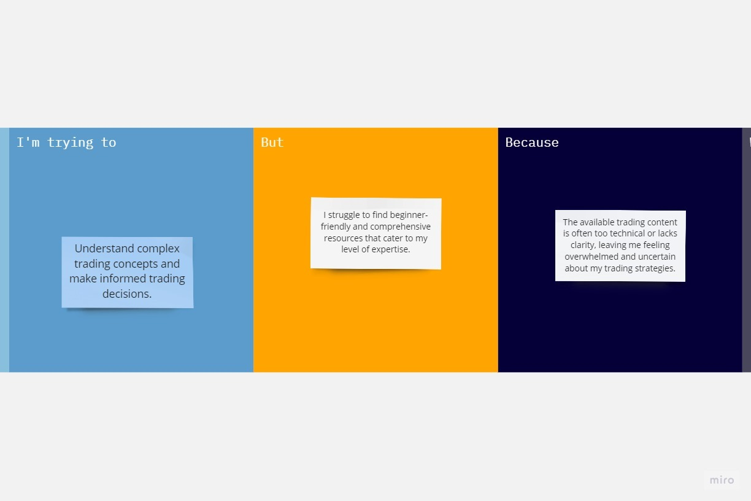

|  |  |  |  |  |  |
| --- | --- | --- | --- | --- | --- |
| **Problem Statement (PS)** | **I am (Customer)** | **I’m trying to** | **But** | **Because** | **Which makes me feel** |
| PS-1 | A novice trader | Understand complex trading concepts and make informed trading decisions | I struggle to find beginner-friendly and comprehensive resources that cater to my level of expertise. | The available trading content is often too technical or lacks clarity, leaving me feeling overwhelmed and uncertain about my trading strategies. | Frustrated and anxious, as I'm unable to gain the knowledge and confidence I need to succeed in the trading world. |
|  |  |  |  |  |  |